1. **Manage Event Details:**
2. **Insert New Event:**

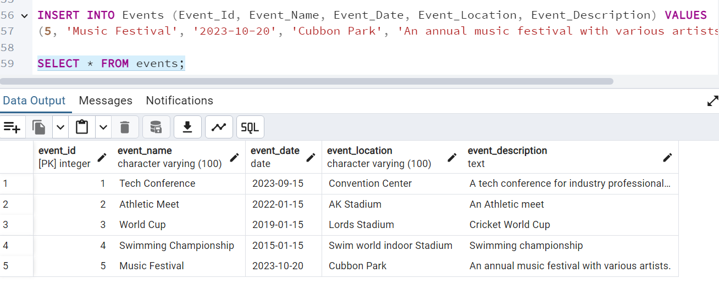

1. **Update Events Information**

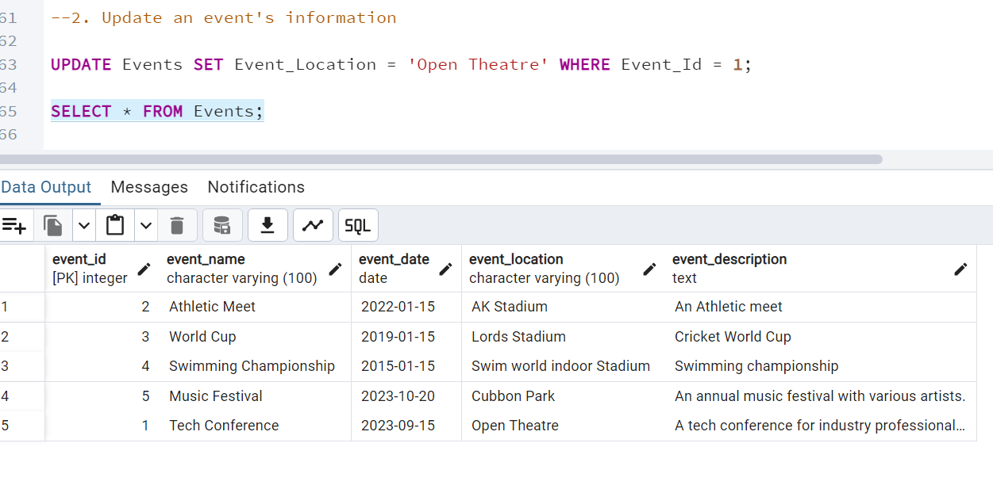

1. **Delete An Event**

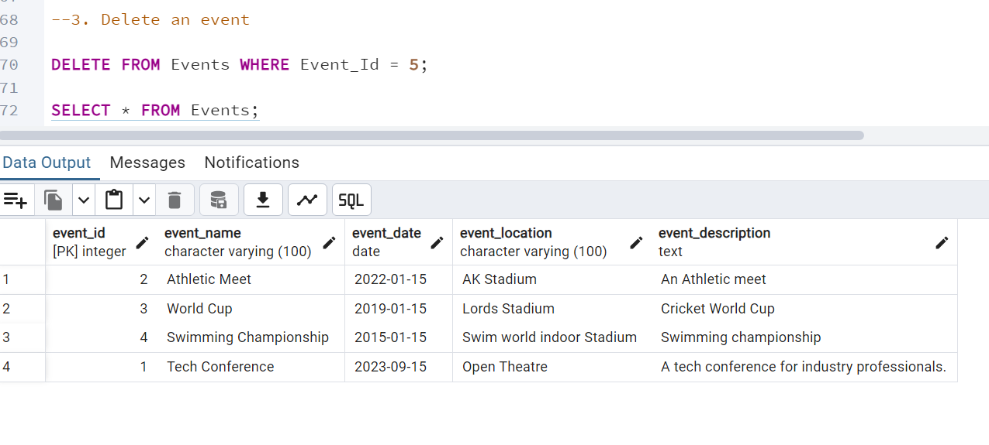

1. **Manage Track Attendees & Handle Events**
2. **Insert a new attendee**

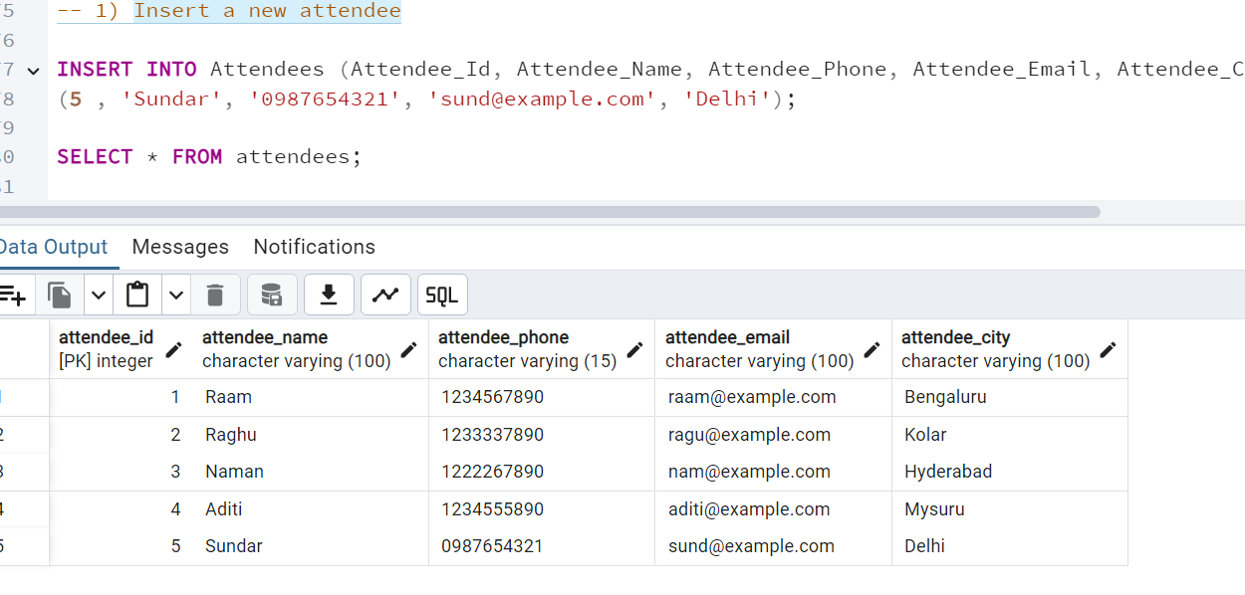

1. **Register an attendee for an event**

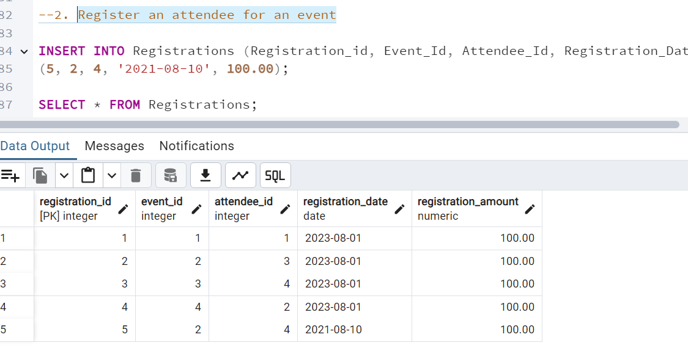

1. **Queries for Event Management:**
2. **Retrieve Event Information:**

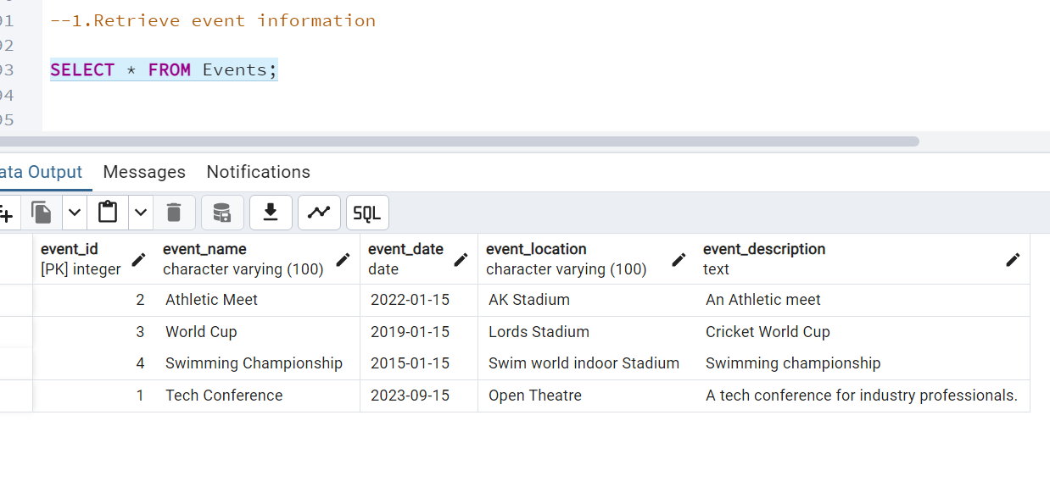

1. **Generate attendee lists**

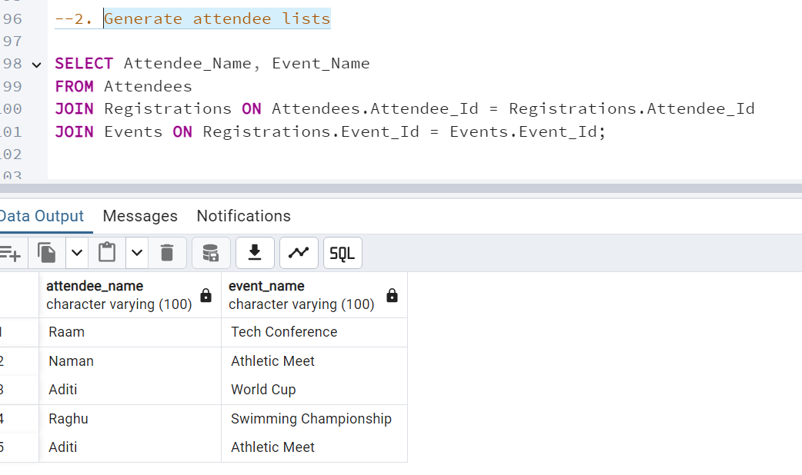

1. **Calculate event attendance statistics**

